CONTENT

* Data analysis and data description.
* Objective
* Lookup and Conditional formatting
* Business questions to be answered using pivot table and dashboard
* Finding insights from pivot table and dashboard.

DATA DESCRIPTION

* show_id type title director cast country date_added release_year rating duration listed_in description

DATA ANALYSIS

* Total number of rows = 8007
* Total number of column = 12
* Total number of movies = 6131
* Total number of TV show = 2676

OBJECTIVE Analyse the movies and TV shows present on Netflix using various excel tools. Answers of some business questions like -

* To find the information about a particular show-id.
* Percentage of type.
* Total number of release of movies and shows per year.
* Ratings of movies and TV shows.
* Top 5 actors of movies and TV shows.
* Top 10 countries of movies and TV shows
* Top 10 genre of movies and TV shows.
* Top 10 directors on Netflix.

TOOLS that have used : Vlookup, Conditional Formatting, Pivot table, Power Query, Slicer, Charts etc.

Final Dashboard:

[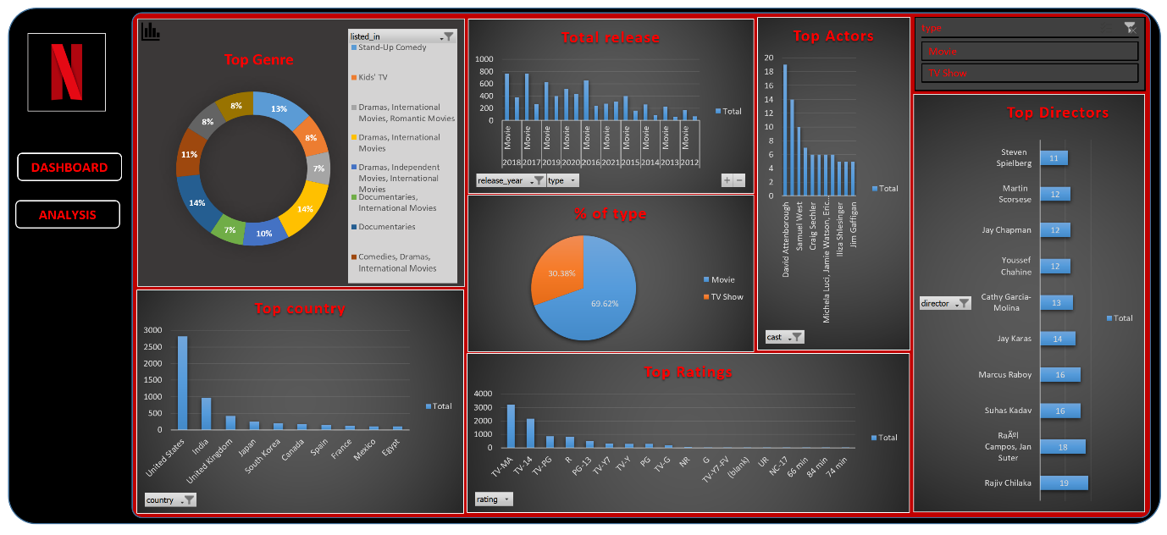](https://user-images.githubusercontent.com/105886845/210431205-51a4f39c-396b-4316-b7b2-1157eda532dd.png)